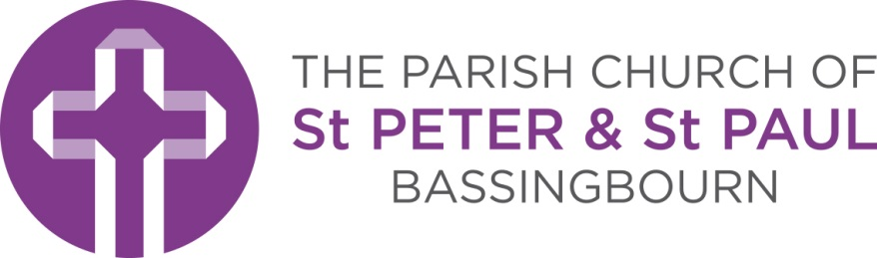

Vicar: The Rev’d Dr. Caroline Yandell
The Vicarage
21 North End
Bassingbourn
Nr Royston
SG8 5NZ

Banns of Marriage Application 2016
Congratulations on your engagement. We are delighted that you want to be married in Church. You will probably be aware that as you are being married in a church other than St Peter & St Paul’s, Bassingbourn you need to have your marriage banns read here as well as where you are being married. In order to do this we need to have the right information. The form below is designed to help us make sure we have this.
Once you have completed it please return this form to:
Church Administrator, Church office, North End, Bassingbourn, SG8 5NZ.
There is a fee for the reading of Banns and issuing of a Certificate of Banns. For 2016 this is £40.
If you have any question about completing the form please feel free to contact the church office on 01763 877558 or office@bassingbournchuch.org.uk .
Once we have received your application we will:
- Inform you of the dates when the banns will be read so you may attend the services when this happens. These will be provisional if the wedding is some time away.
- Invoice you prior to the first reading of the Banns
- Send you the Certificate of Banns after the last reading. This is important – without this certificate the wedding cannot go ahead!
Marriage is more than a ceremony and we are here to support you both individually and together in the build up to your wedding and importantly in the years after. Please feel free to contact us at any time now or in the future.

Banns of Marriage Application
To be completed if you live in the Parish of St Peter & St Paul, Bassingbourn
but are getting married elsewhere.
If filling in electronically please type in the grey boxes which will expand as you type.
If filling by hand please write clearly and in CAPITALS
Section 1 | Groom’s details |  |  |  |  |  | Bride’s details
Surname: |  |  |  |  |  | Surname:
First names:  (as on birth certificate) |  |  |  |  |  | First names:  (as on birth certificate)
Age at proposed date of marriage: |  |  |  |  |  | Age at proposed date of marriage:
Nationality: |  |  |  |  |  | Nationality:
Marital status: Single Widow Divorced  Please mark appropriate box |  |  |  |  |  | Marital status: Single Widow Divorced  Please mark appropriate box
Do you live in the Parish of  St Peter & St Paul, Bassingbourn? |  |  |  | The Groom lives in the Parish  The Bride lives in the Parish
If you are not sure you can check at www.achurchnearyou.com/parishmap
Address:  Postcode: |  |  |  |  |  | Address:  Postcode:
Home phone:  Mobile:  Email: |  |  |  |  |  | Home phone:  Mobile:  Email:
How long have you  lived at this address? |  | Years Months |  |  |  | How long have you  lived at this address? |  | Years Months
Section 2 | Wedding and church details
Date of wedding:
Name and address of Church where wedding is to take place:
Section 3 | Declaration
I certify that to the best of my knowledge these answers are correct.  Signed |  |  |  |  |  | I certify that to the best of my knowledge these answers are correct.  Signed

Return to: Church Administrator, Church Office, North End, Bassingbourn, SG8 5NZ

