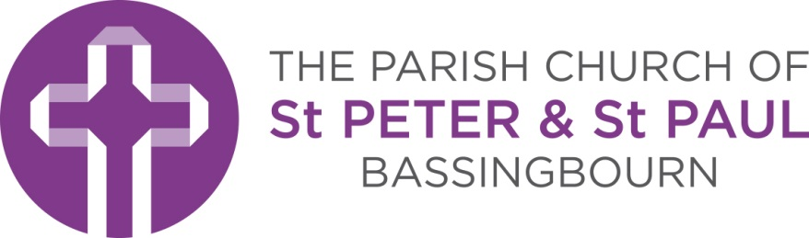

Church Office
23 North End
Bassingbourn
Nr Royston
SG8 5NZ

Marriage Application
Congratulations on your engagement. We are delighted that you want to be married at the Parish Church of St Peter & St Paul, Bassingbourn.
We are here to help you as you prepare for your wedding. To help ensure that everything goes smoothly we need some information from you. Please complete the attached form and return it to us at the address on the bottom of the form. Please make sure you fill it in carefully – do contact the Church Office if you have any queries about the form.
Once we have received your application we will arrange a meeting with you and our Minister. At this meeting we can confirm your eligibility, discuss your detailed plans and possible dates for the wedding when both the Church and the Minister are available. Please do not set a fixed date for the wedding prior to the meeting.
Marriage is more than a ceremony and we are here to support you both individually and together in the build up to your wedding and importantly in the years after. Please feel free to contact us at any time now or in the future.

Please return this form to: Church Administrator, Church Office,
North End, Bassingbourn, SG8 5NZ
or email it to office@bassingbournchurch.org.uk

Marriage Application
Parish Church of St Peter & St Paul, Bassingbourn
Please complete and return this form to: Please return this form to: Church Administrator,
Church Office, North End, Bassingbourn, SG8 5NZ or email it to office@bassingbournchurch.org.uk
If filling in electronically please type in the grey boxes which will expand as you type.
If filling by hand please write clearly and in CAPITALS
Please contact us if you have any queries with the form at office@bassingbournchurch.org.uk
Section 1 | Personal Details
Groom’s details |  |  |  |  |  | Bride’s details
Surname: |  |  |  |  |  | Surname:
First names:  (as on birth certificate) |  |  |  |  |  | First names:  (as on birth certificate)
Date of birth: |  |  |  |  |  | Date of birth:
Age at proposed date of marriage: |  |  |  |  |  | Age at proposed date of marriage:
If either of you will be under 18 at the date of your marriage the permission of your parents must be obtained: please discuss this with us as soon as possible.
Nationality: |  |  |  |  |  | Nationality:
Marital status: Single Widow Divorced  Please mark appropriate box |  |  |  |  |  | Marital status: Single Widow Divorced  Please mark appropriate box
If divorced:  when did that  marriage end?  is your previous  spouse still alive |  |  |  | Month Year  Yes No |  | If divorced:  when did that  marriage end?  is your previous  spouse still alive |  |  | Month Year  Yes No
Address:  Postcode: |  |  |  |  |  | Address:  Postcode:
How long have you  lived at this address? |  |  |  |  | Years Months | How long have you  lived at this address? |  |  |  | Years Months
You must prove your nationality and residence in the Parish: please bring your passports and a recent utility bill for the address(es) you have given above at the first meeting.
Home phone :  Mobile :  Email : |  |  |  |  |  | Home phone :  Mobile :  Email :
Address after marriage
(if different)
Occupation: |  |  |  |  |  | Occupation:

Parents / step parents details You may have the details of up to four Parents / step parents details on the Marriage Document. Please complete those you wish to have included. If retired, state previous occupation and enter ‘retired’ in brackets
Groom |  |  | Bride
Father’s  full name: |  |  | Father’s  full name:
Father’s  occupation: |  |  | Father’s  occupation:
Mother’s  full name: |  |  | Mother’s  full name:
Mother’s  occupation: |  |  | Mother’s  occupation:
Step parent’s  full name: |  |  | Step parent’s  full name:
Step parent’s occupation: |  |  | Step parent’s occupation:
Step parent’s  full name: |  |  | Step parent’s  full name:
Step parent’s occupation: |  |  | Step parent’s occupation:
Section 2 | Wedding details
Approximately when are you planning to get married? |  |  |  |  | Month Year
Although we will do our best to meet your preferred date please do not set a specific date until we have confirmed the availability of the Church and Minister.
Section 3 | Eligibility
Do you live in the Parish? |  | The Groom lives in the Parish  The Bride lives in the Parish
If you are not sure you can check at www.achurchnearyou.com/parishmap
If one of you does NOT live in the Parish of St Peter & St Paul’s then you must arrange for your Banns to be called in your local Parish Church, that is the Church whose parish includes the address at which you are presently living.
If neither of you live in the Parish you can only marry at the Church if you have a connection with the Parish. Please select any of the following that apply.
For more information see http://www.yourchurchwedding.org/youre-welcome/more-churches-to-choose-from.aspx.
I have previously lived in the Parish for a period of at  least 6 months. |  |  |  |  |  | Groom Bride
I was baptised in the Parish. |  |  |  |  |  | Groom Bride
I was prepared for confirmation in the Parish. |  |  |  |  |  | Groom Bride
I have previously regularly gone to normal church services in the Parish Church for a period of at least 6 months. |  |  |  |  |  | Groom Bride
My parents, since I was born, have lived in the Parish for a period of at least 6 months or have regularly gone to normal church services in the Parish Church for a period of at least 6 months. |  |  |  |  |  | Groom Bride
My parents or grandparents were married in the Parish. |  |  |  |  |  | Groom Bride
Section 4 | Declaration This can be done at the first meeting
I certify that to the best of my knowledge these answers are correct.  Signed |  |  |  | I certify that to the best of my knowledge these answers are correct.  Signed

